User Manual for the pyCES + pyCESViewer programs
Background: The pyCES and pyCESViewer programs were developed at NOAA CSL to operate the small cavity enhanced spectroscopy instruments. In a CES instrument, a broadband light emitting diode (LED) illuminates a cavity filled with an ambient sample. The light that exits the cavity is directed into a grating spectrometer to yield an intensity spectrum as a function of wavelength. The difference between the intensity spectrum measured out of cavity filled with ambient air containing absorbing trace gases, and a cavity filled with some non-absorbing gas, yields the concentration of that trace gas.
The code to run a CES instrument does several things:
- Maintains a temperature-stabilized light LED output by means of a thermoelectric cooler (TEC) set to a certain temperature setpoint
- Captures the spectral intensity measured by the spectrometer at regular intervals (which defines the time resolution of the instrument)
- Directs the flow into the cavity, and periodically sequentially introduces a non-absorbing gas (usually zero air) and a second gas with known Rayleigh scattering (usually helium), via a set of two flow controllers and two solenoid valves
- Monitors the temperature and pressure within the cavity
- Saves the data to be processed later
In previous CES instruments, all of these tasks were achieved by a laptop computer running LabView, which was communicating with a number of off-the-shelf signal processing devices. However, the newest generation of miniaturized CES instruments are designed to be used on drones, backpacks, or other small platforms, and may not be always be able to accommodate a full laptop.
Therefore, these instruments are operated in a split configuration, with a small microprocessor (in this case, a Beaglebone Black) communicating directly with the individual components (i.e. the spectrometer, the flow controllers, etc) and saving the data in the python-based pyCES program. Concurrently, a laptop operates the LabView-based pyCESViewer program, which allows the user to observe real-time data and run calibrations, but can be disconnected without disturbing the data collection. A schematic showing this design is below.
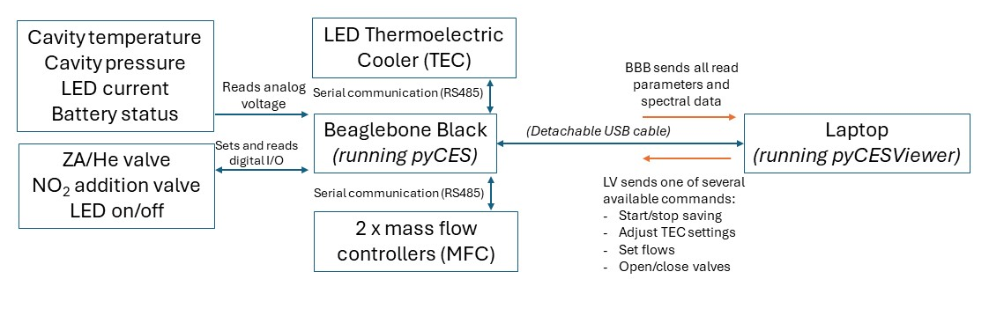
pyCES
This code can be found at https://github.com/carrie-womack/pyCES. The main function is called run_pyCES.py, and it calls each of the following subroutines:
- MFC.py – reads the mass flow controller output data and sets flows
- TEC.py – reads the data from the Meerstetter TEC-1092 module, including the temperatures of the LED and the heatsink, and reports the current and voltage of the TEC, as well as the TEC status and whether the LED temperature is stable. It also allows you to set certain parameters
- analog.py – reads the data from the analog channels (cavity temperature and pressure, temperature within the box, the battery voltage when used, and the LED current
- gpio.py – sets and reads three digital I/O ports as high or low (i.e. 1 or 0 or on/off).
- config.py – reads the config file (called config.yaml) for certain user-defined parameters
- ocean_spectrometer.py – sets spectrometer parameters and reads the spectrometer data
- save_data.py – saves data
- upd.py – communicates with the pyCESViewer program running on the laptop
There is also a configuration file, called config.yaml, that allows the user to change certain parameters. A screenshot of this file is below, and is organized by component. Most of these should not be changed without good reason. However, there are some parameters that may need to be changed:
- Each section has an “enable” keyword, which allows the user to enable or disable components, if they are not present. 1 = enable, 0 = disable.
- In spectrometer: the user may need to adjust the spectrometer integration time (in microseconds) to avoid saturating the detector
- In MFC: different MFCs output different data, so the appropriate header should be selected to match the data frame. More information can be found in the Alicat user manuals
- In analog: The pressure sensors need to be calibrated appropriately, so Pres_offset and Pres_slope allow the user to specify that calibration.
- In save: minToSave indicates how many minutes will elapse before a new file will be created, and location indicates where data should be saved. Both of these could be adjusted.
Usage:
- Apply power to the instrument. Connect the BBB-laptop USB cable
- Wait ~1 minute for the BBB to turn on, then connect via SSH (debian@192.168.7.2)
- If the BBB is connected to the internet, the date/time will be set automatically, but if not, set it manually: sudo date -s “YYYY-MM-DD HH:MM:SS”. Use time.gov if exact time is required.
- Type “sp”, which activates the python virtual environment. The terminal should now read
$(.CES-env)debian@beaglebone:
- Navigate to /home/debian/pyCES
- If required, change any parameters in the config file and save it
- Run the program by typing “python run_pyCES.py”
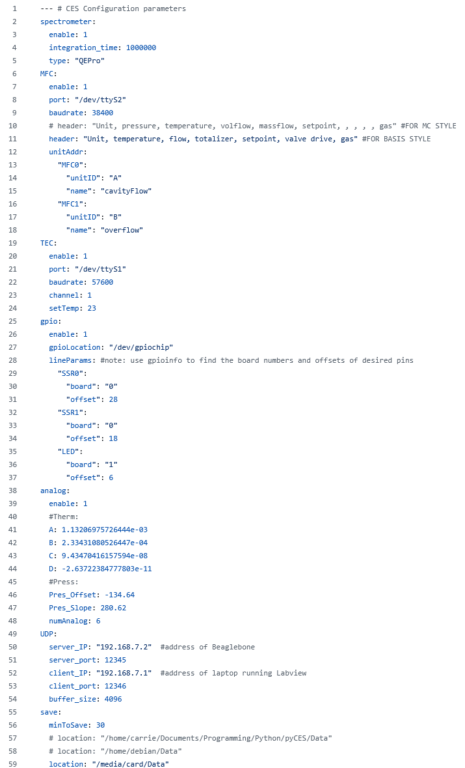
pyCESViewer
This code can be found at https://github.com/carrie-womack/pyCESViewer. Download it as a zipped folder, extract it anywhere on your computer, open pyCESViewer.lvproj and then select Main.vi
The code has three major purposes:
- Display and process real time data, including spectral data, temperatures, flows, valves, etc.
- Allow the user to manually adjust certain parameters (flows, temperature setpoints, certain valves)
- Allow the user to add an Action to the queue. An Action is a set of bundled instructions that is often repeated during the normal performance of the instrument. These Actions can either be run once or set to automatically repeat at a certain frequency. Parameters of the Action are user-defined and found in the config file. More on this below
The following screenshots show the major features of the program. You will also notice that there are three tabs on the main grey box. The following two screenshots show the contents of the second and third tabs.
The first tab shows the spectral data, the auxiliary data (pressures, temperatures, flows, valves), and also plots the auxiliary data as a function of time.
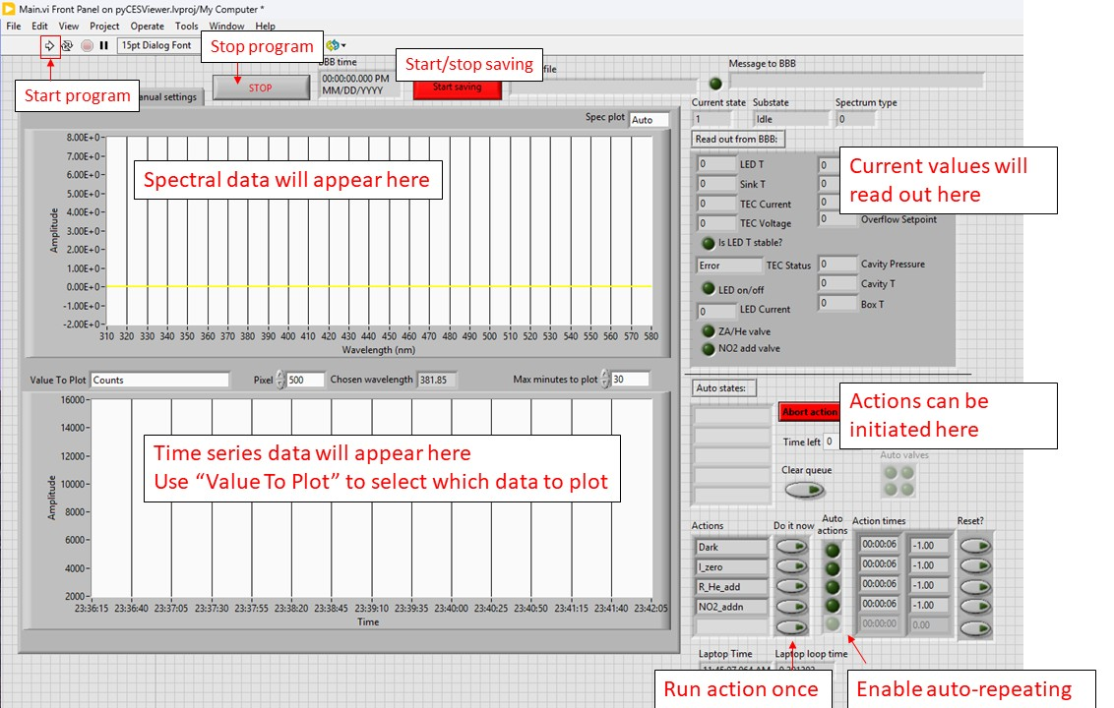
The second tab will show the latest mirror reflectivity measurement and dark background. But this will only occur after at least one dark (Dark) and one reflectivity (R_He_add) autostate have been completed.
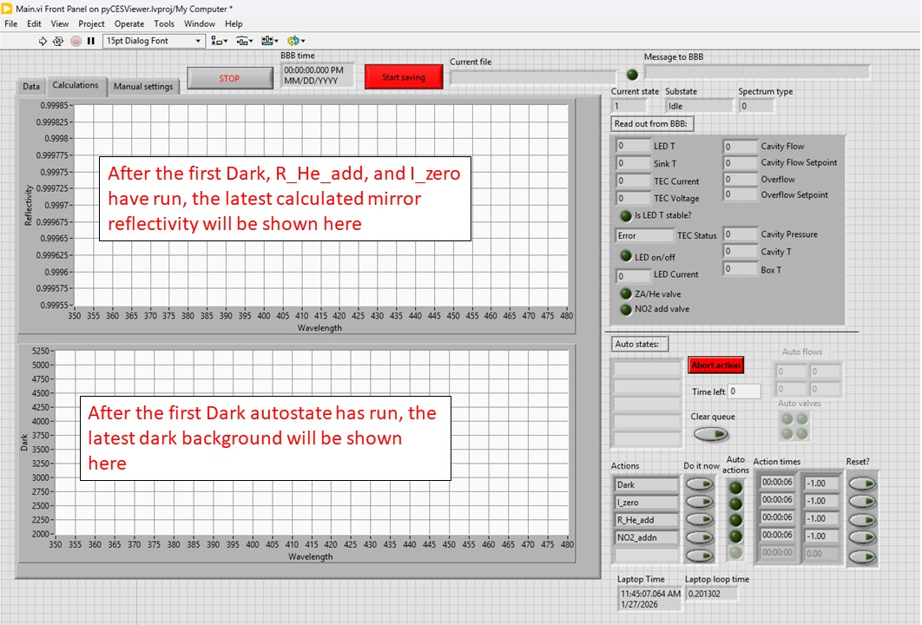
The third tab is where the user can make certain manual adjustments.
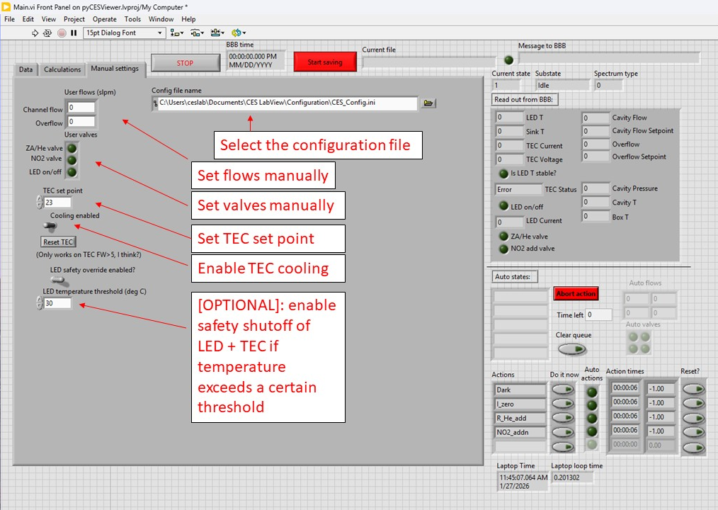
Let’s now take a look at the configuration file. There are five sections, which we will go through one by one. Note that “;” indicates a comment that will be ignored:
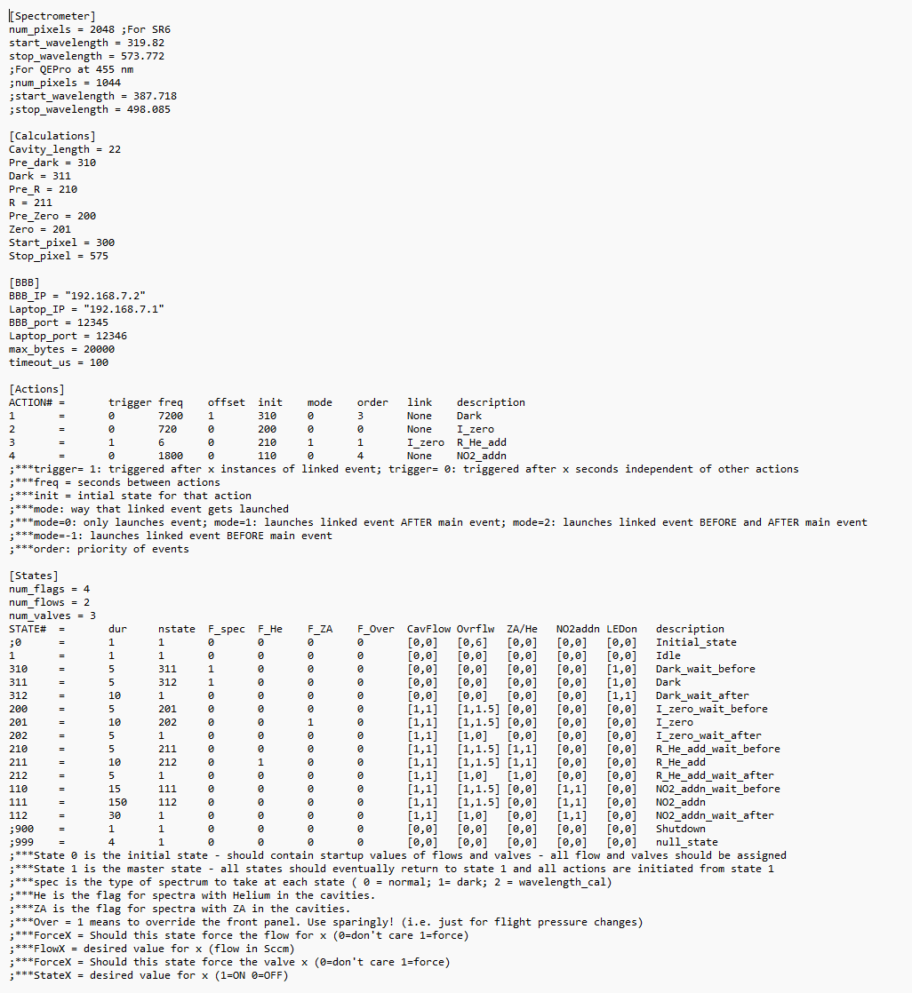
[Spectrometer] – contains parameters related to how the spectral data will get displayed on the first and second tabs
- Num_pixels: the number of pixels in the spectrometer. The QEPro has 1044 while the SR6 has 2048
- Start_wavelength: The wavelength (nm) that corresponds to the first pixel. Find this in the spectrometer datasheet calibration (First Coefficient in the wavelength calibration section)
- Stop_wavelength: The wavelength that corresponds to the last pixel. We are assuming a linear wavelength calibration here, so take the Second Coefficient in the wavelength calibration and multiply it by the number of pixels. This will give us an approximate stop wavelength
[Calculations]
- Cavity length: Enter the cavity length in cm. It can be approximate, as this is just for displaying an approximate mirror reflectivity
- Pre-Dark through Zero: State numbers corresponding to each type of spectrum, for calculation purposes. You will probably not need to change these.
- Start_pixel and Stop_pixel: These designate the region of interest to calculate R, and scrubs the rest. It’s mostly for display cleanliness, and you can approximate these by finding the wavelength range of the LED, and converting to pixels using the spectrometer wavelength calibration data
[BBB] - These are communication parameters for the UDP communication with the Beaglebone. You will hopefully not need to adjust these.
[Actions] – These lines describe the timing of the actions, and can seem a little complicated at first. You can add additional actions if needed, but make sure to maintain this format.
Actions can either be run once, or set to auto mode. Additionally, there are two types of actions: linked and unlinked. Unlinked actions run normally. Linked actions also force an additional action to be added to the queue (such as R_He_add, which forces I_zero to happen right after it). Here are the other columns:
- Trigger: Indicates trigger mode. 0 = repeat this state every X seconds, listed in the Freq column. 1 = repeat this state every X instances of the linked state.
- Freq: Either gives the number of seconds between each repeated state (if trigger = 0), or the number of instances of the linked state before repeating this state (if trigger = 1).
- Offset: Ignore, deprecated
- Init: Labels the state number associated with this action. See [States] section below
- Order: Ignore, deprecated
- Link: Name of the linked action
- Description: This is what shows up in the front panel.
Here is an example: In this file, the Dark action is unlinked, so if it is run once, it will begin running state 310 (see Dark_wait_before state in the [States] section below). If automode is enabled, it will repeat every 7200 seconds (2 hours). By contrast, the R_He_add is linked to I_zero, so when it is selected, it will also add I_zero to the queue. It will begin running state 210 (again, see states section below). If automode is enabled, it will run automatically add R_He_add to the queue after every 6 instances of I_zero. This can be useful if you want to do a zero every 720 seconds (20 minutes), but only want to do a helium addition on a subset of these.
[States] – This describes what should actually physically happen when an action begins. You will notice that many of the states are in groups of three, allowing the user to define a given state, plus a wait before and a wait after state. The first column is the state number associated it. The next columns are:
- Dur: The duration (in seconds) of the state.
- Nstate: what the next state will be. For example, Dark_wait_before (state 310) has 311 as the next state, indicating that when Dark_wait_before is finished, it should next go to state 311 (Dark).
- F_spec, F_He, F_ZA, F_Over: Flags for pyCESViewer to interpret these states. You will probably not need to change these
- The next five columns indicate the settings for the two flow controllers (Cavity Flow, and Overflow), and three valves (ZA/He, NO2 addition solenoid valves, and the LED on/off setting). Each takes the form of [X,Y], where X indicates whether the program should force a new value (X=1) or just leave it the way it is (X = 0). Y indicates the value, and represents flow in slpm for the first two columns, and 1/0 for on/off for the last three.
For example, let’s examine states 200, 201, and 202, labeled as I_zero_wait_before, I_zero, and I_zero_wait_after. Notice that in the [Actions] section, the Action labeled I_zero indicates it will jump right to state 200 first. That will force the cavity flow to be 1 slpm, and the overflow to be 1.5 slpm. This is good because we want the overflow to be higher than the cavity flow. This state lasts 5 seconds, then jumps to state 201, which has the same settings. State 201 will last for 10 seconds, and then will jump to state 202. In this state, cavity flow is still forced to be 1 slpm, but the overflow is now 0 slpm. This state lasts for 5 seconds, and then it returns to state 1 (Idle).
Why have three states for each action? Well, when the data gets processed, it will designate the middle state as the actual zero, and will throw out the before and after data.
The most likely things you will want to change in the section is the duration and the flow rates.

Usage:
- On the manual settings tab, make sure the correct config file is selected.
- On the BBB, start the pyCES program as described in that section
- In LabView, start the program by clicking the white arrow in the top left.
- You should see data coming through.
- On the manual settings tab, flip the Enable Cooling switch, and ensure that the TEC Status box has changed to Running. On the Data tab, select LED T in the time series plot and watch to make sure the temperature stabilizes. When it does, the Is LED T stable? circle should light up.
- On the manual settings tab, turn on the LED with the LED on/off switch, and wait for the temperature to stabilize again.
- If you want to take data, click the Save button to start saving
- On the manual settings tab, change the channel flow to the desired flow
- In the Actions section, add Dark and R_He_add to the queue.
- Take data
- When read to shutdown, stop saving, turn the LED off, turn the flows back to 0. Click Stop (NOTE! DO NOT click the little stop sign icon at the top. Only use the Stop button).
- On the BBB, type Ctrl + C to stop pyCES.
- Get the data using FileZilla or another FTP program
- Shutdown the Beaglebone
- Remove power from the instrument

